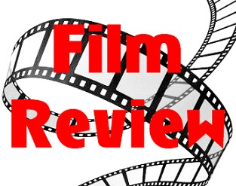

What rating? (1-100%)?

Plot

Did you like it? Why did you like or didn´t like it?

Settings

Main characters

Picture

Type of film ___________________________

Title ___________________________________________________________________